GUARDRAILS
1. ACCESS CONTROL
A. Target Users
AA. Admin Seats
- 4 Admin Seats:
- Sherry Segovia – CEO and President
- Cris Araya – Chairman
- Ralph Ranie Saura - DCSO
- IT Department – IT TL and IT Assoc.

- Department Head Seats:
- Mary Grace Espinoza – HRBP
- Sharlyn Tolentino – SMM
- Marianne Longasa – OM
- Prensesa Juangco – OM
- Mary Grace Acidilla – OM
- Robert Liton – Inventory TL
- Jehandy Quinampay – Cashier TL
- Donald Rey Saberon – Procurement TL
- Dave Enrikko Capuno – Auditor TL
- Maria Elena David – Housekeeping TL
- Romelyn Bajar – Housekeeping TL
- Ana Mae Morato – Housekeeping TL
- Dr. Carlos Martinez – Chief Veterinarian MKT
- Dr. Michelle Mame – Chief Veterinarian ALB
- Dr. Marion Manuel – Chief Veterinarian GH
- Jenine Ann Naig – Veterinarian Technician TL MKT
- Cyrine Soriano – Veterinarian Technician TL ALB
- Kenneth Joshua De Leon – Veterinarian Technician TL GH
- Mark Anthony Cañeso – Clinic Assistant TL ALB
- Mark Jonel Remolacio – Clinic Assistant TL GH

      - Employee Seats:
        - All employees that are not in Admin Seats and Department Head Seats

AB. Permissions
- Access per function/module
Legend:
Full = Manage permitted records subject to task workflow rules
Edit = Update permitted fields or make an authorized review decision
Create = Create permitted assignments or reports
View = Read permitted records
Select = Choose an available option
None = No access

TASK MODULE
Functions | Admin Seats | Department Head Seats | Employee Seats
Task access | View all records; workflow rules apply | EVP by management assignees; OM and Chief Vet by branch; TL by department; Corporate broad access | Own assignments and other permitted task involvement
Task creation | Permitted management creation | Eligible assignments; Chief Vet home-branch restriction; TL own work requires approval | Standard creation currently blocked; report and authorized child delegation rules are separate
Review | Only designated review actions where authorized | Designated reviewer or coordinator; ordinary self-review blocked | Only specifically authorized child review
Opening Rounds | Access follows task action rules | IT TL can start, complete directly or dismiss today; other heads have no automatic performer right | Eligible IT staff in permitted branches submit for review
Intern weekly reports | View; reviewer authority remains separate | IT TL review supported; EVP intended access has a current server gap; OM and Corporate supervisory access blocked | Assigned intern only
Workspace Setup | Full | None unless signed-in account is Admin | None
Logs and history | View permitted records; no log deletion | View permitted records; no log deletion | View permitted records; no log deletion
2. WORKFLOWS
No. | Module | Test Data Covered
1 | Task Module access and assignment | TM01–TM07
2 | Task timing review and collaboration | TM08–TM14
3 | Reports and repeating tasks | TM15–TM19
4 | Task handover and shared records | TM20–TM25
5 | Import / Export | TM26
Test Data Credentials
- Admin testing: Sign in using the Admin account. Enable Show Admin setup controls when testing Workspace Setup.
- EVP testing: Sign in using the Admin account. Under View as role, Select EVP and the employee being tested.
- Operations Manager testing: Sign in using the Admin account. Under View as role, Select Operations Manager and the manager or branch being tested.
- Corporate Services testing: Sign in using the Admin account. Under View as role, Select Corporate Services and the member being tested.
- Chief Vet testing: Sign in using the Admin account. Under View as role, Select Chief Vet and the veterinarian or branch being tested.
- IT Supervisor testing: Sign in using the Admin account. Under View as role, Select Team Leader, then the IT Supervisor.
- Team Leader testing: Sign in using the Admin account. Under View as role, Select Team Leader, then the department leader being tested.
- Employee testing: Sign in using the Admin account. Under View as role, Select Employee, then the employee being tested.
- IT employee or intern testing: Sign in using the Admin account. Under View as role, Select Employee, then the IT employee or intern being tested.
Record the selected role and employee in each test case’s Test Credentials field. For example, “Admin account — View as role: Team Leader — Selected person: Mark Jay Ricalde.”
These tests use Admin preview. Record successful results as Passed in Admin preview. Actual server-permission checks remain unverified when performed through preview because the signed-in account retains its Admin permissions.
Admin account preview must be removed before the live release.

TD- No. TM01 – Task Module
Route: /task-module and related record actions
Test Scenario: While signed in as Admin, the tester selects a non-Admin role through View as role and checks whether Workspace Setup is hidden. The tester opens the Workspace Setup URL to observe how the preview handles access.
Test Credentials: Admin account — View as role: non-Admin role used during testing — Selected person: IT Intern (Employee).
Test Data: One signed-in Admin account, the selected preview role and person, Show Admin setup controls disabled, and URL /task-module?view=Workspace%20Setup.
Expected Result: Workspace Setup is unavailable with Admin setup controls disabled. Opening its URL returns the preview to an allowed page.
Actual Result: Redirected to Dashboard.
Status: PASSED
Tester: David Santos
Screenshots:

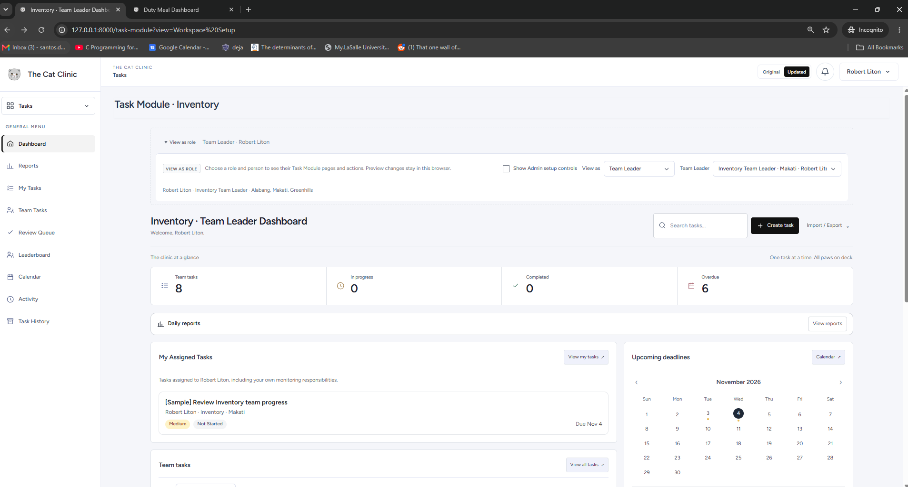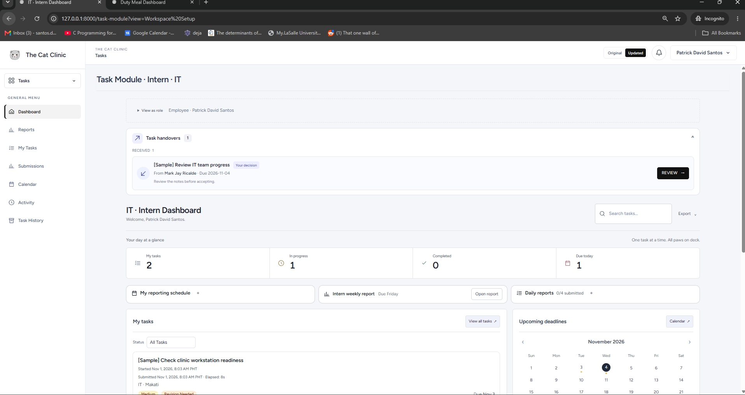

TD- No. TM02 – Task Module
Route: /task-module and related record actions
Test Scenario: An authorized creator saves a task with missing required fields, then tries a starting date later than its deadline. A corrected version with complete details is saved to check both rejection and successful creation.
Test Credentials: Admin account — View as role set to Team Leader — selected test leader
Test Data: Task title Validation Test; one attempt with an empty title or description; one attempt with start date 10 November 2026 and deadline 9 November 2026; corrected
deadline 11 November 2026; an eligible assignee and valid department, branch and priority.
Expected Result: Missing required fields and starting date after deadline are rejected clearly.
Actual Result: Required Field Messages for Empty Fields and Starting Date adjust to deadline date if, user tries to set the starting date after the deadline date.
Status: PASSED
Tester: David
Screenshots: 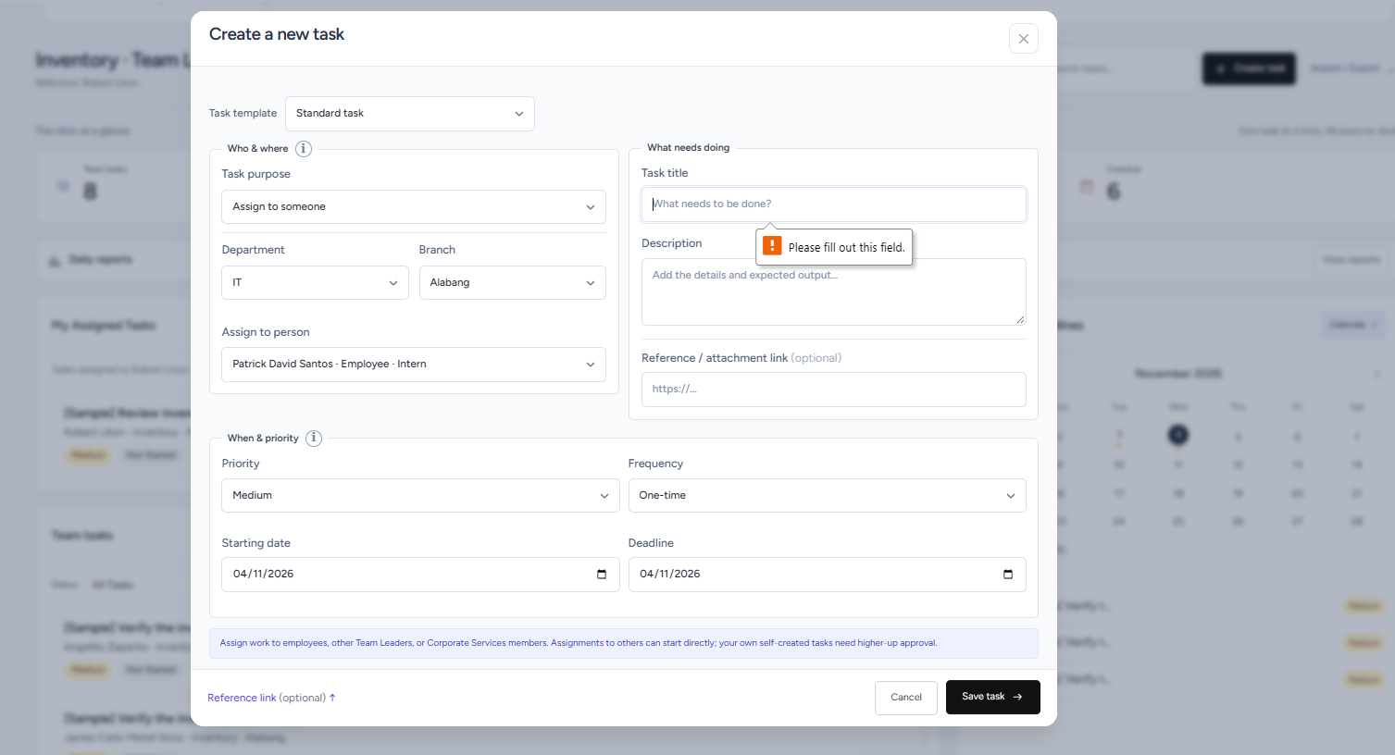
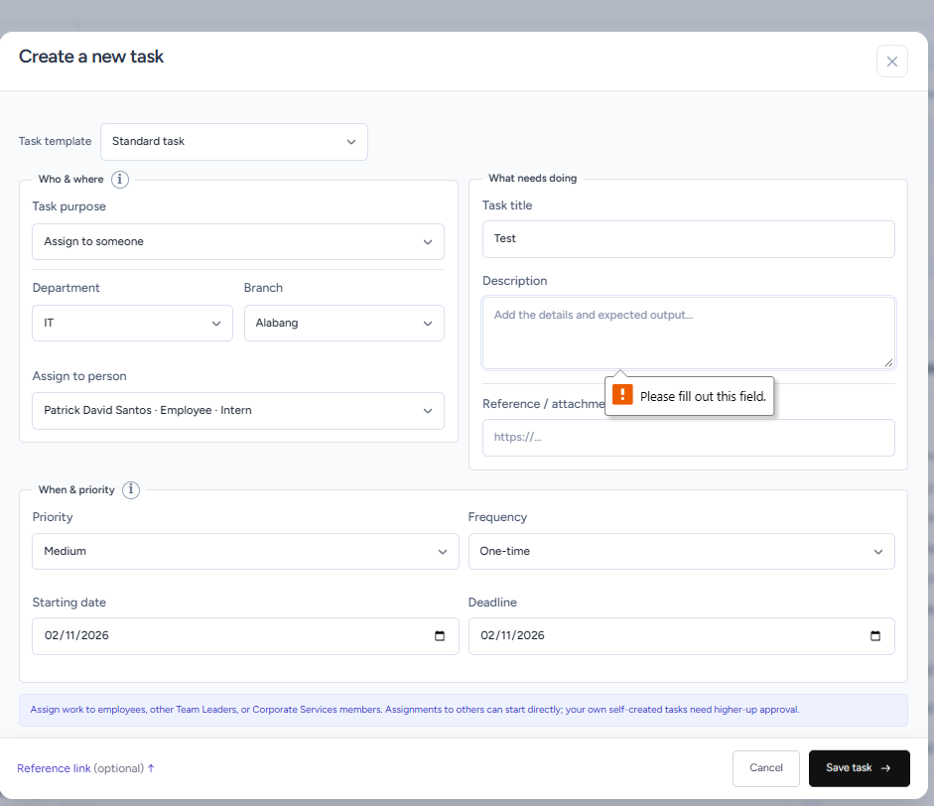

TD- No. TM03– Task Module
Route: /task-module and related record actions
Test Scenario: A Team Leader assigns a standard task to another eligible employee. The resulting status and the employee’s ability to start are checked to confirm that OM pre-start approval is not added to an ordinary assignment.
Test Credentials: Admin account — Team Leader preview, then assigned-person preview
Test Data: Creator Mark Jay Ricalde; assignee Patrick David Santos where currently eligible; department IT; branch Makati; task TL Assignment Test; starting date on the test day and deadline after it.
Expected Result: TL assigns another eligible employee. Work does not need OM pre-start approval.
Actual Result: TL assigns another eligible employee. Work does not need OM pre-start approval.
Status: PASSED
Tester: David Santos
Screenshots:
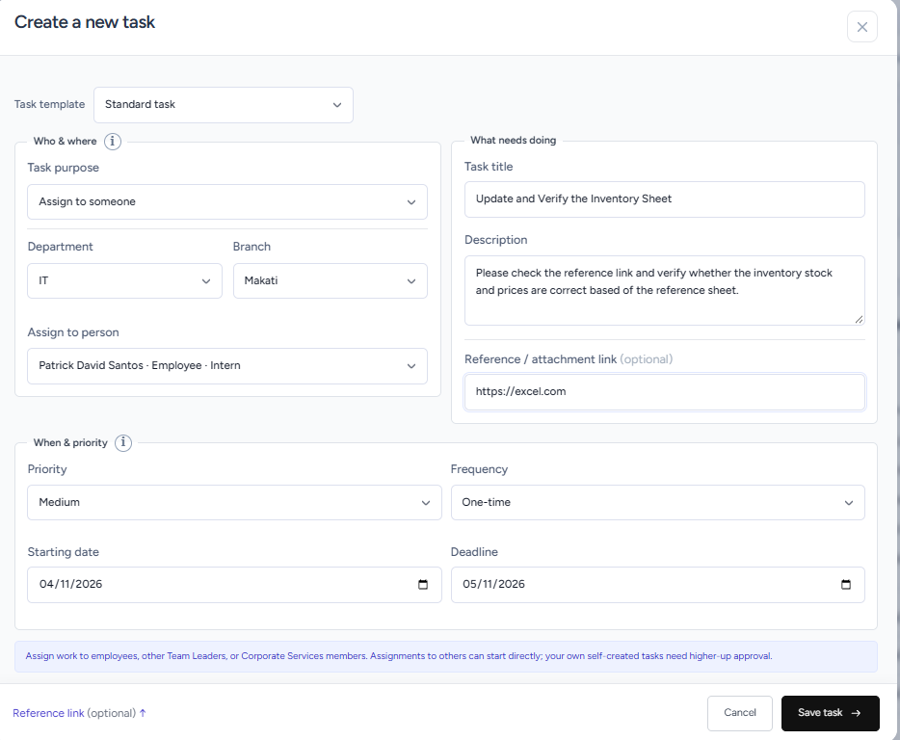
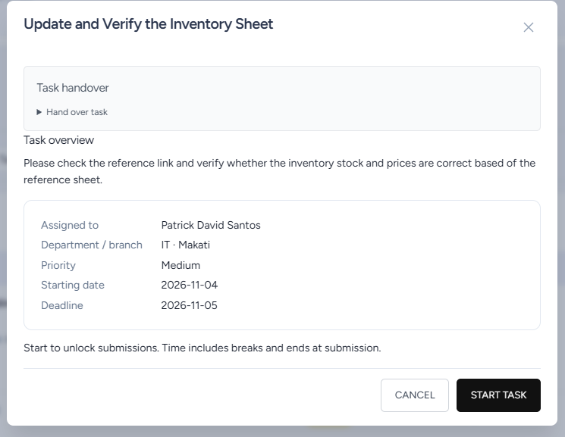
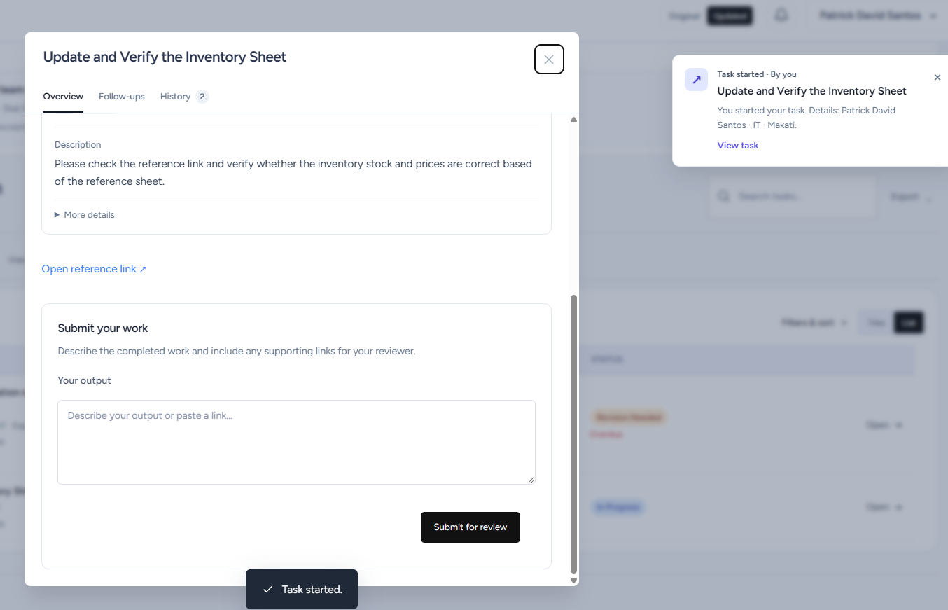

TD- No. TM04 – Task Module
Route: /task-module and related record actions
Test Scenario: A Team Leader creates a request for work they will perform themselves. Starting and submission are checked before approval and again after the designated approver accepts the request.
Test Credentials: Admin account — Team Leader preview, then designated approver preview
Test Data: Mark Jay Ricalde requesting a task for himself; Makati branch; title Self-created Approval Test; status Pending Approval; the approver actually named on the saved request.
Expected Result: The request remains Pending Approval until approved. Starting and submission become available afterward.
Actual Result: Pending Approval, blocked work controls and the approved task.
Status: PASSED
Tester: David Santos
Screenshots:
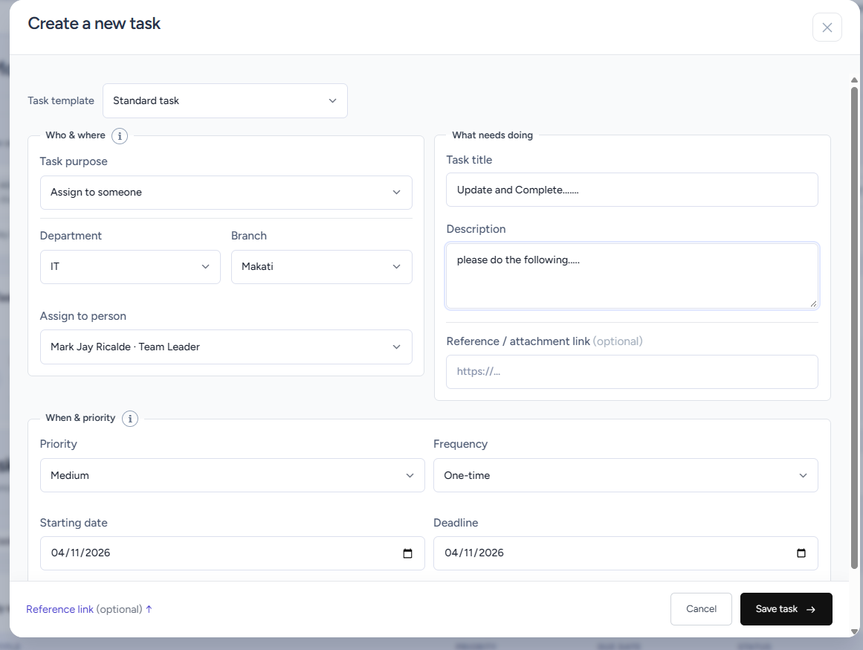
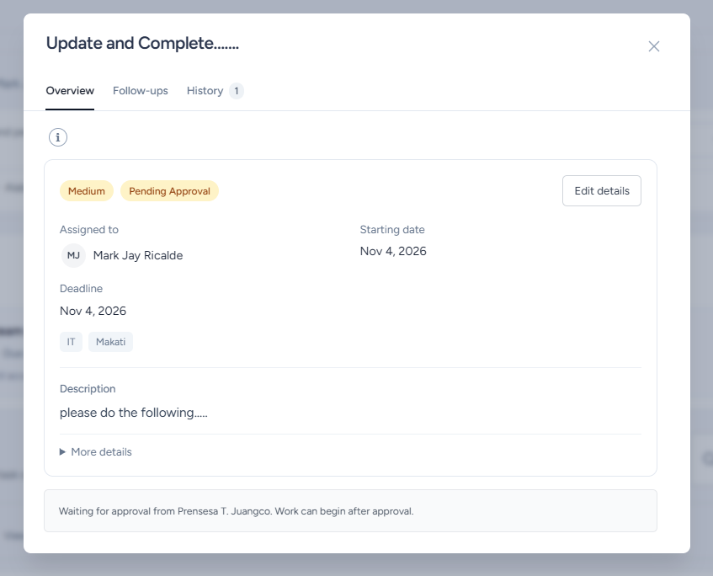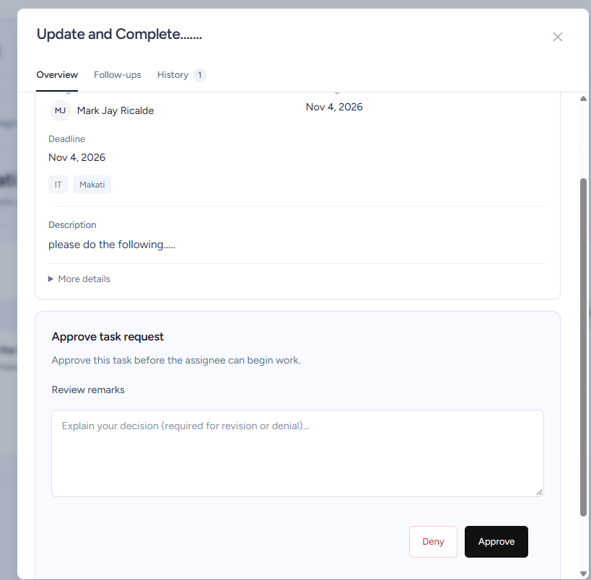
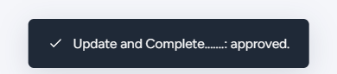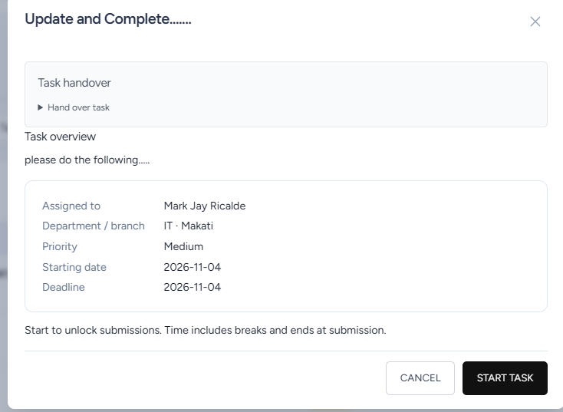

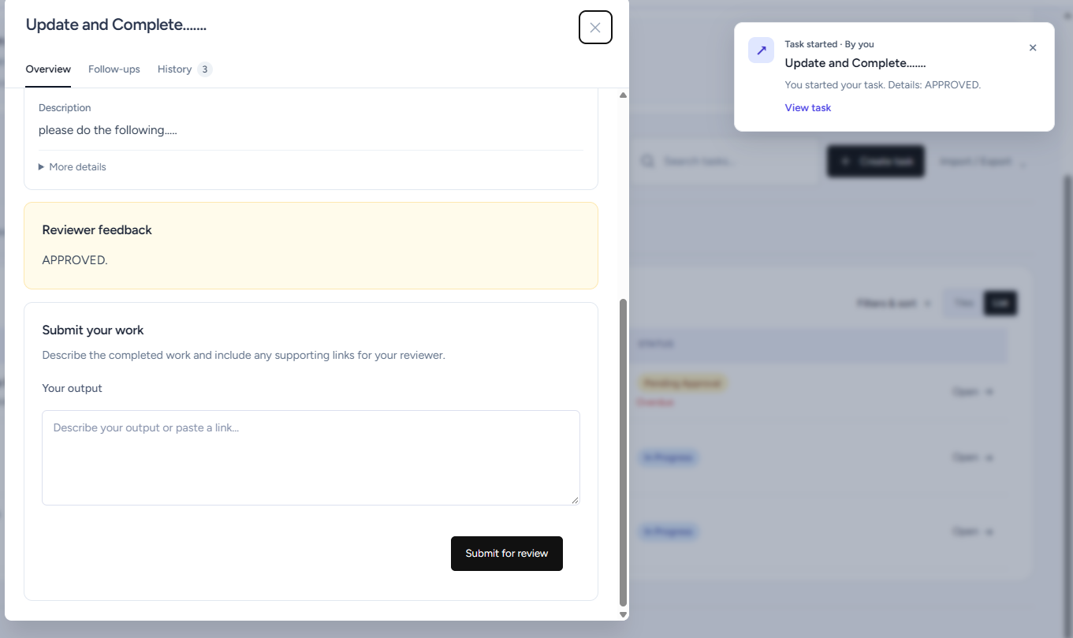

TD- No. TM05 – Task Module
Route: /task-module and related record actions
Test Scenario: Using the corresponding role and person previews, the requester, an unrelated manager and the designated approver each attempt to approve the same
pending request. The case checks that approval belongs to the named approver and cannot be granted through requester or unrelated-manager access.
Test Credentials: Admin account — switch View as role and selected person as required for this scenario. Record the roles and people actually used.
Test Data: One Pending Approval self-created request by Mark Jay Ricalde at Makati; Prensesa Juangco if named as approver; Mary Grace Acidilla as unrelated manager. Record any difference in the actual configured approver.
Expected Result: Requester and unrelated manager cannot approve; independent designated reviewer can.
Actual Result: Requester and unrelated manager was not able to approve, only the designated reviewer can.
Status: PASSED
Tester: David Santos
Screenshots:
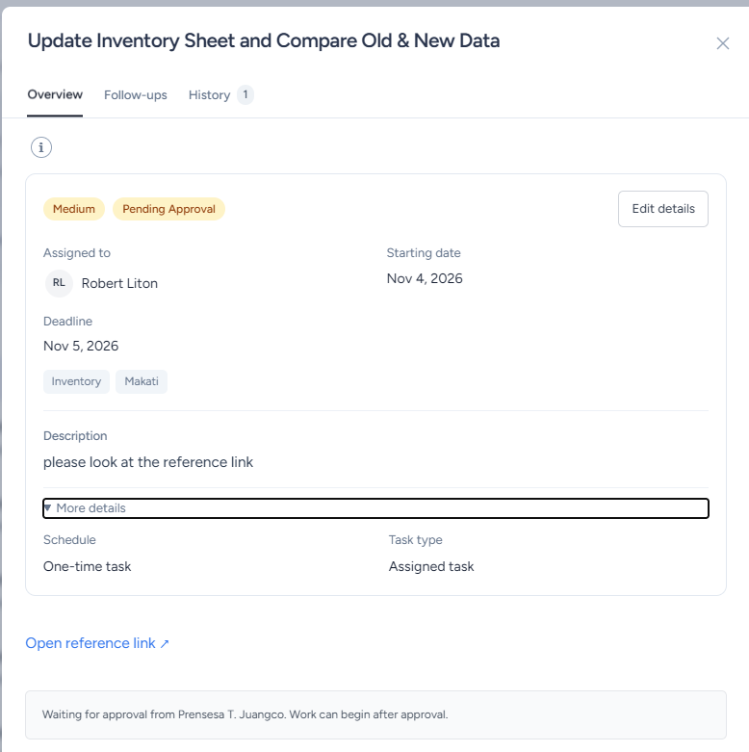
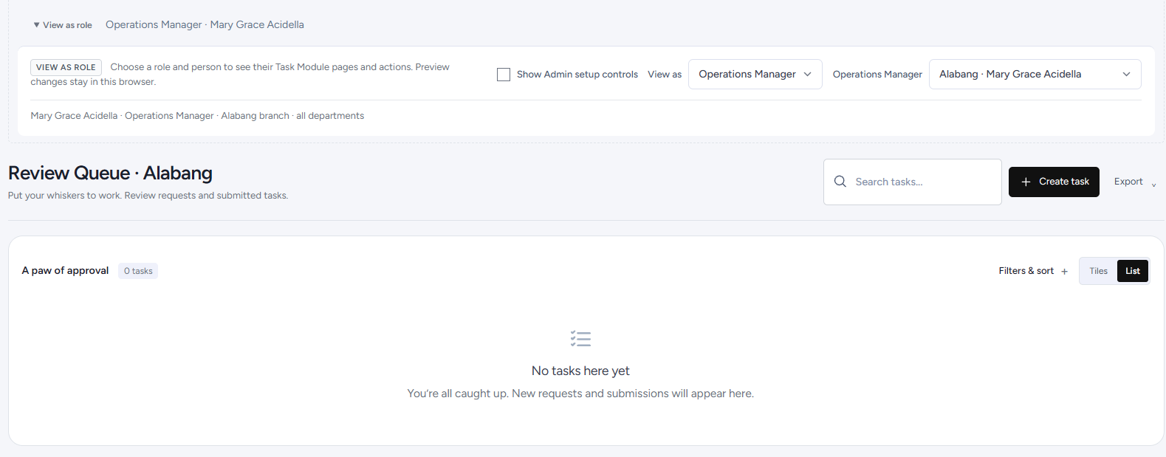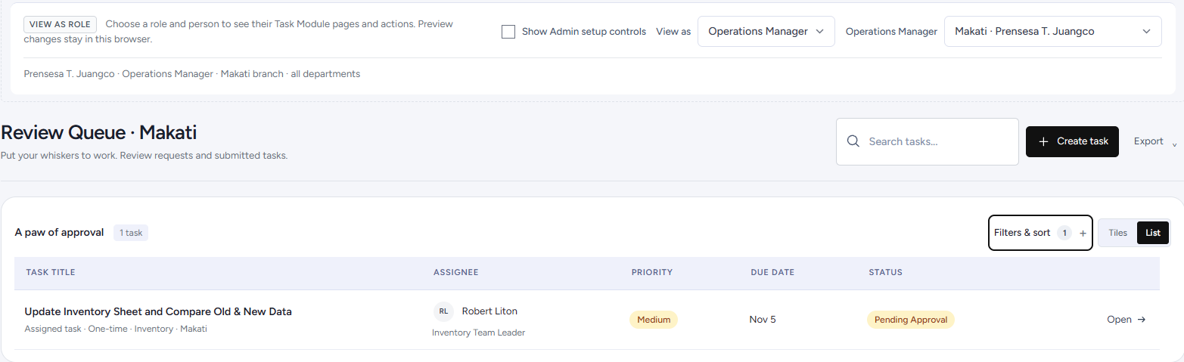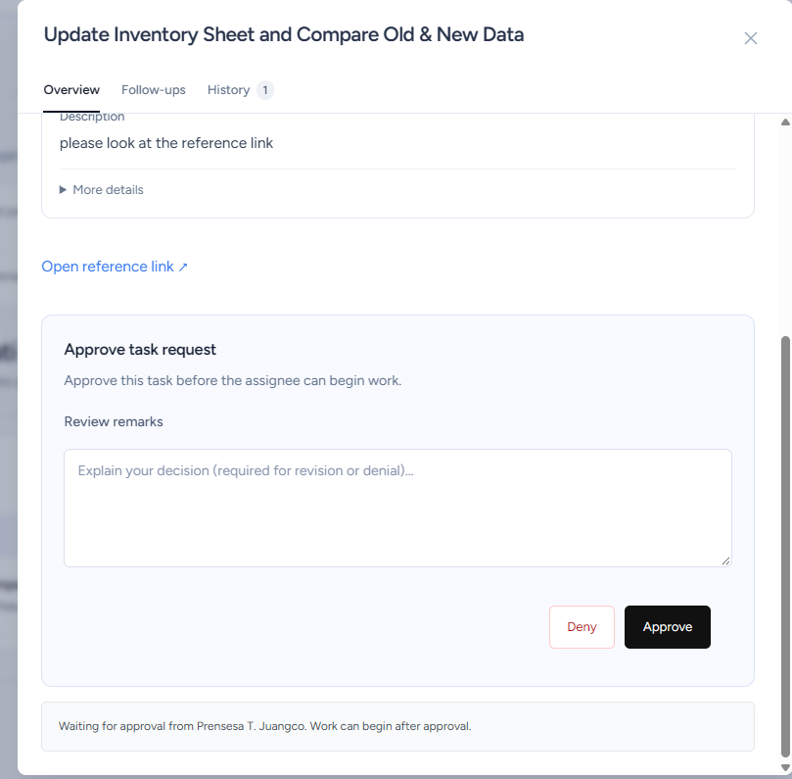
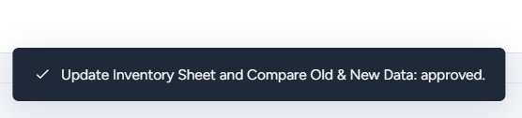

TD- No. TM06 – Task Module
Route: /task-module and related record actions
Test Scenario: The assigned person opens an unstarted task and attempts submission before starting. After starting and submitting valid output, the recorded start, submission and elapsed times are compared with the observed actions.
Test Credentials: Admin account — preview as the assigned person
Test Data: An unstarted standard assignment with starting date reached; sample output Computer check completed; recorded clock time immediately before Start task and at submission.
Expected Result: Submitting without Start is blocked. Valid submission has server time and elapsed time.
Actual Result: Submission Tab is blocked unless task starts. Submissions displays start time and latest submission time.
Status: PASSED
Tester: David Santos
Screenshots:
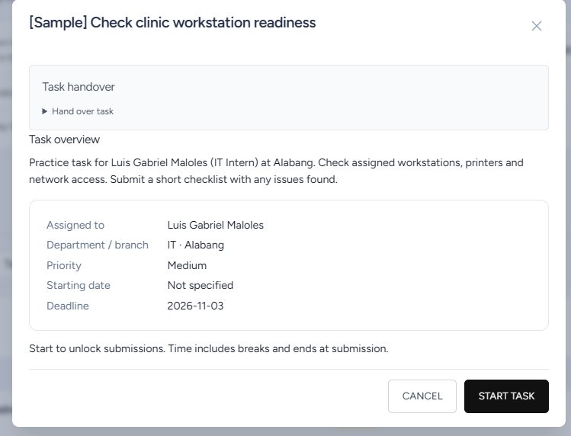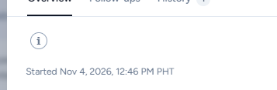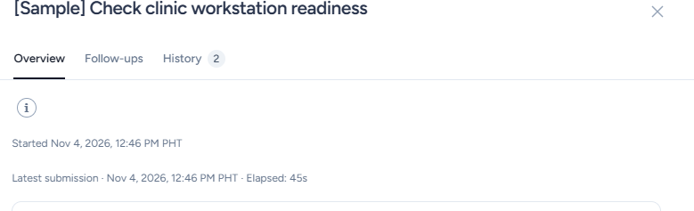

TD- No. TM07– Task Module
Route: /task-module and related record actions
Test Scenario: In Team Leader preview, the tester attempts to start it or change the employee’s output. The assigned employee performs the same actions to check that work controls follow ownership.
Test Credentials: Admin account — switch View as role and selected person as required for this scenario. Record the roles and people actually used.
Test Data: Task Ownership Test; assignee Patrick David Santos; viewer Mark Jay Ricalde; sample output Computer checked; a standard individual assignment rather than shared Opening Rounds.
Expected Result: Another visible user cannot start or edit the owner’s work.
Actual Result: Another cannot start a task that was assigned to someone else.
Status: PASSED
Tester: David Santos
Screenshots:
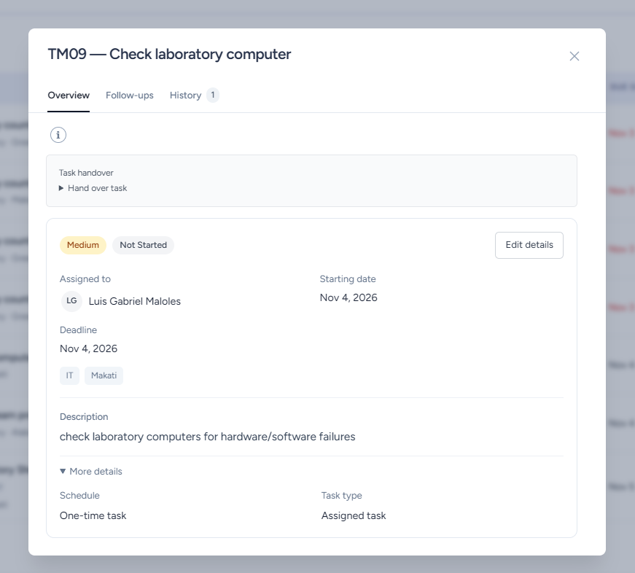
Team Leader View
Team Leader cannot start or edit employee work.
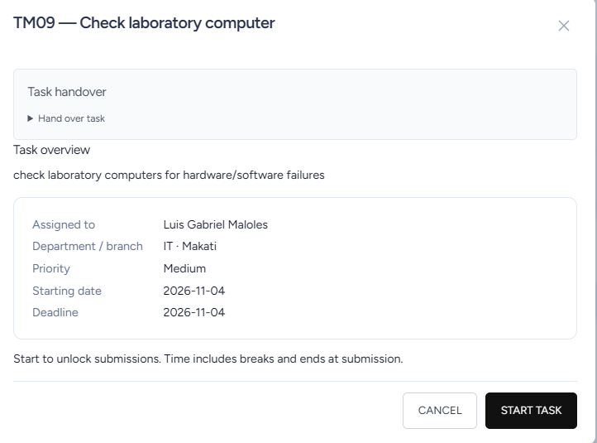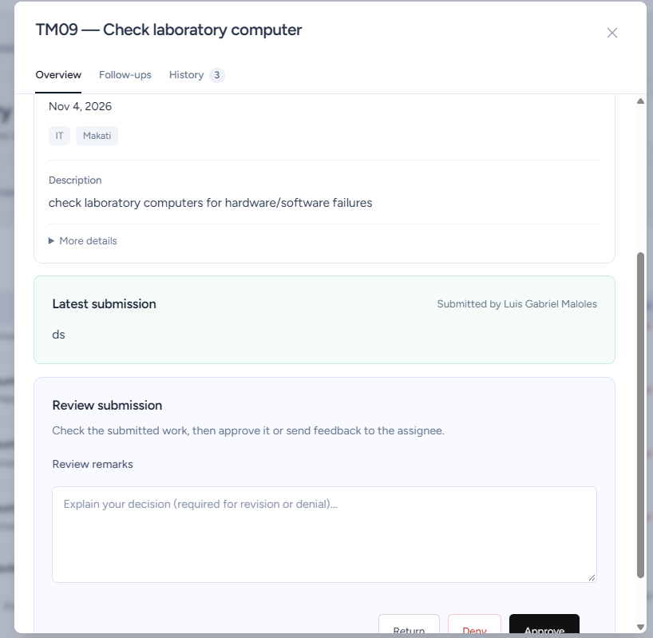
Employee View
TD- No. TM8 – Task Module
Route: /task-module and related record actions
Test Scenario: A designated reviewer attempts to return/deny submitted work with empty remarks/unrelated text and is required to provide feedback. Approval remarks remain optional.
Test Credentials: Admin account — assigned-person and designated-reviewer previews
Test Data: One Pending Review task and empty review remarks
Expected Result: Missing Return or denial remarks are denied unless reviewer adds feedback.
Actual Result: Missing Return or denial remarks are denied. Requires reviewer to add feedback.
Status: PASSED
Tester: David Santos
Screenshots:
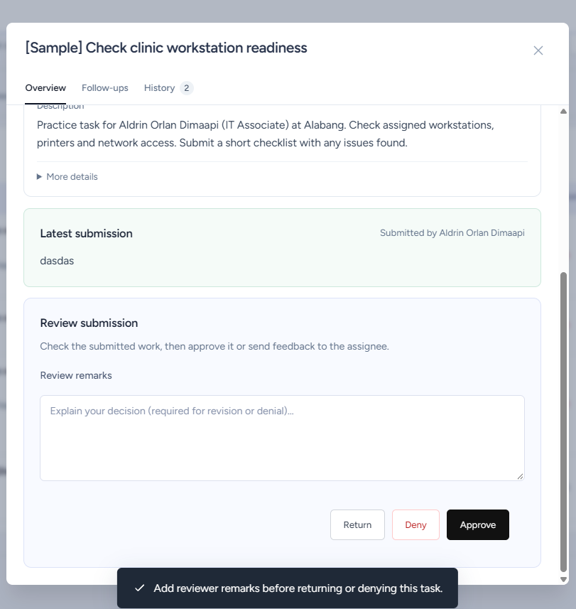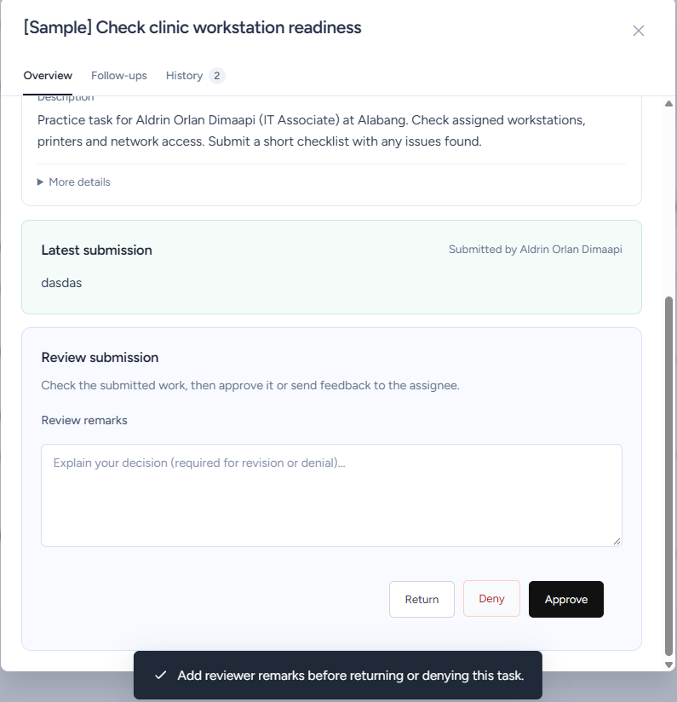
TD- No. TM9 – Task Module
Route: /task-module and related record actions
Test Scenario: The main task owner create adds the final deadline and assigns a coordinator whose deadline is the day after the final deadline. The coordinators child task assignment should also follow this scenario.
Test Credentials: Admin account — Main task owner and coordinator.
Test Data: Main Task / Coordinator Mark Jay Ricalde and invalid deadline
Expected Result: The user should not be allowed to set the coordinator deadline after the final deadline date. This should also apply for child tasks.
Actual Result: The coordinator deadline should not allow the user to set the deadline be after the final deadline date. (This applies with child tasks)
Status: PASSED
Tester: David Santos
Screenshots:
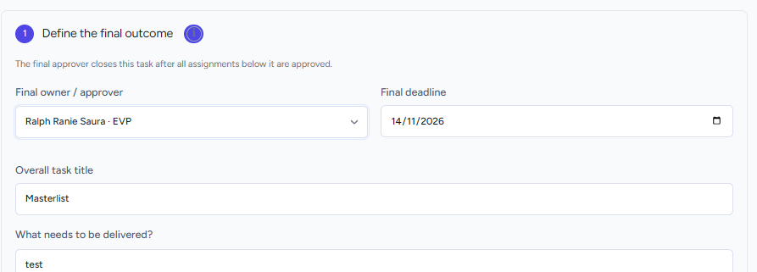
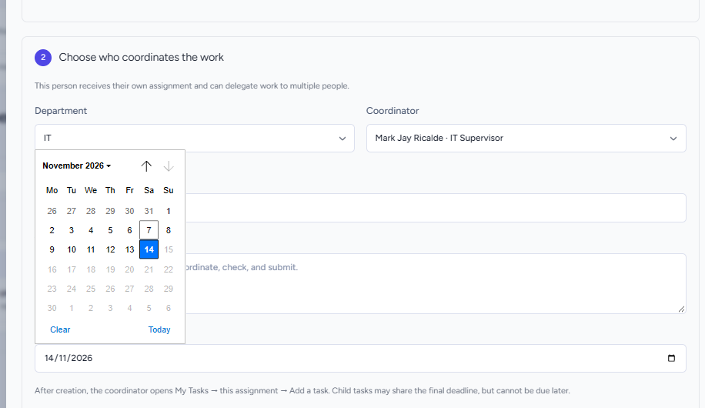

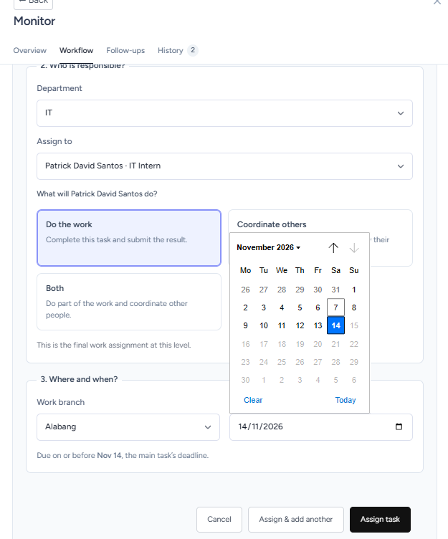
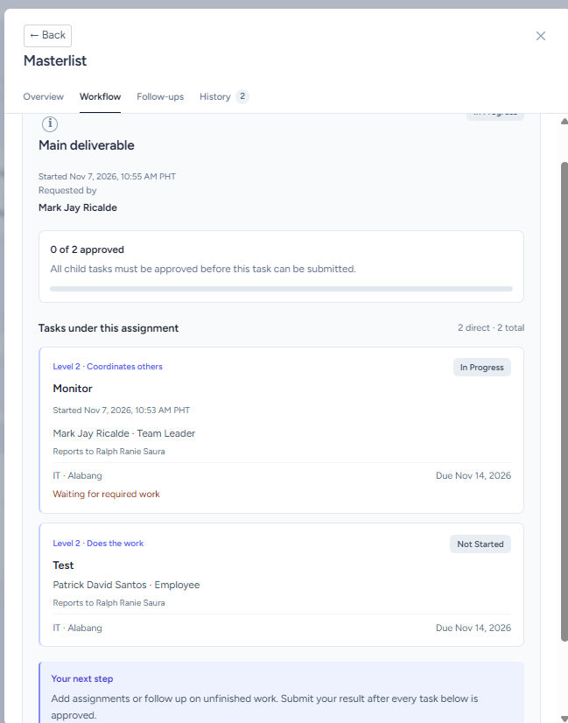

TD- No. TM10 – Task Module
Test Scenario: Using EVP preview, check that tasks assigned to OMs, Corporate Services members and Team Leaders directly under the EVP appear in the task list. Check that ordinary employees are unavailable in the person filter and assignment choices.
Test Credentials: Admin account — View as role: EVP — Selected person: Ralph Ranie Saura
Test Data: Task Create through EVP preview, Assignee Roles.
Expected Result: The task create view for EVP should only display OM, Corporate Services, and Team Leaders. Employees should be unavailable in the task assignment choices.
Actual Result: The task create view for EVP should only display OM, Corporate Services, and Team Leaders. Employees should be unavailable in the task assignment choices.
Status: PASSED
Tester: David Santos
Screenshots:
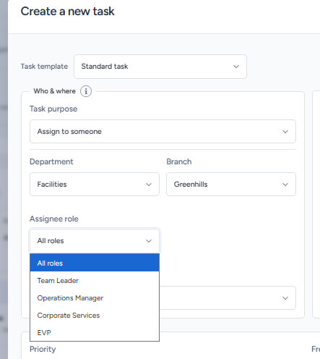

TD- No. TM11 – Task Module
Route: /task-module and related record actions
Test Scenario: An IT intern weekly report is opened by its owner, IT Supervisor, EVP and unrelated roles. The case checks allowed report access and records the known EVP access mismatch if it is still present.
Test Credentials: Admin account — switch View as role and selected person as required for this scenario. Record the roles and people actually used.
Test Data: Opening Rounds/Narrative Reports, IT Supervisor, EVP, OM, Corporate Services and unrelated Employee accounts
Expected Result: OM and unrelated employee or Corporate user cannot access another intern’s weekly report.
Actual Result: OM and unrelated employee or Corporate user cannot access another intern’s weekly report.
Status: PASSED
Tester: David Santos
Screenshots:
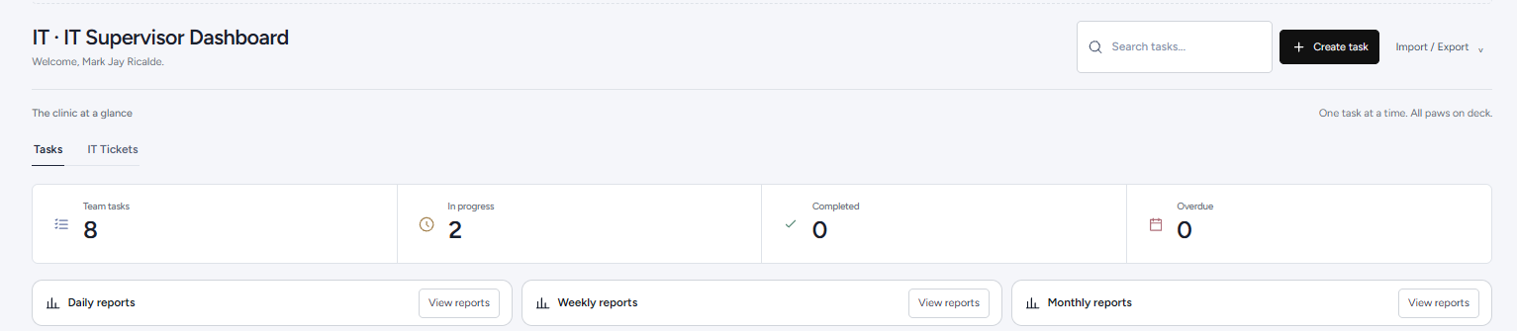
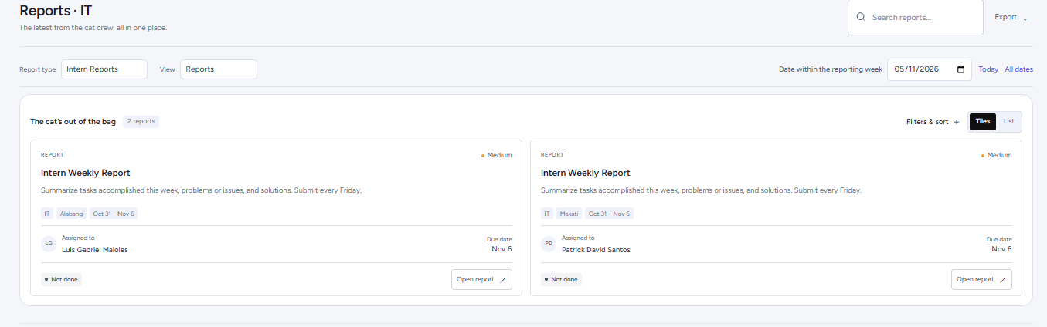
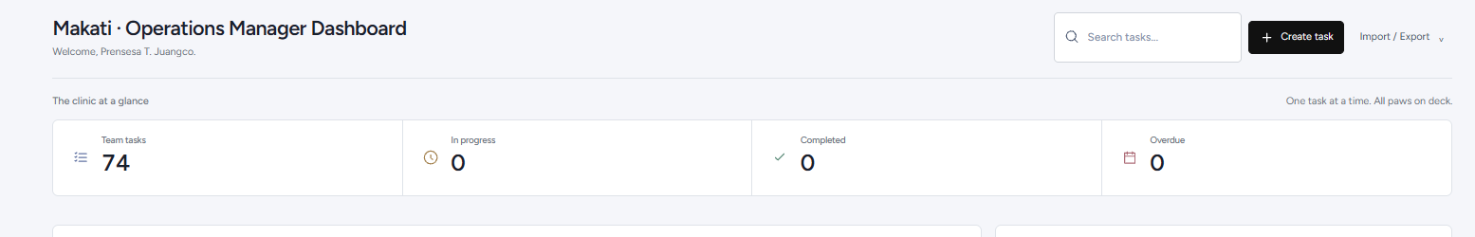

TD- No. TM12 – Task Module
Route: /task-module and related record actions
Test Scenario: Two eligible IT person previews open Opening Rounds for the same branch and date. One user saves work and the other refreshes to check that both use one shared report and see the same result.
Test Credentials: Admin account — switch View as role and selected person as required for this scenario. Record the roles and people actually used.
Test Data: Two eligible IT accounts; one branch available to both; one test date; the same shared Opening Rounds record; a saved checklist result and report count before and after.
Expected Result: Two IT users opening one branch/date see a single shared report.
Actual Result: Two IT users opening one branch/date see a single shared report.
Status: PASSED
Tester: David Santos
Screenshots:
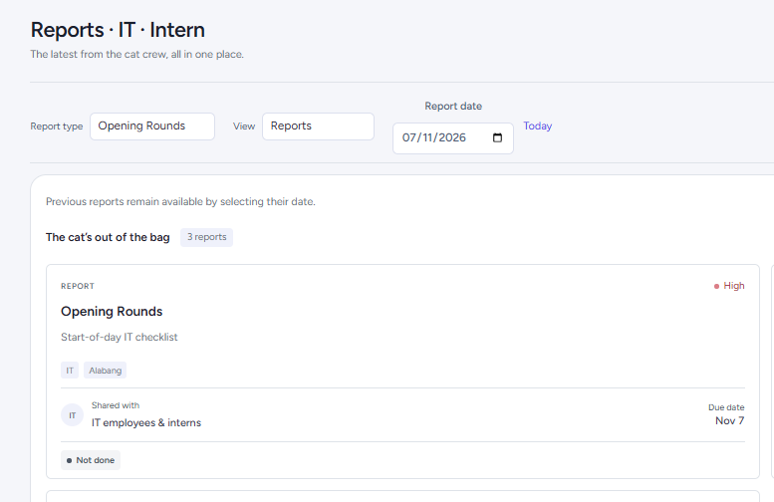
Employee: Patrick David A. Santos
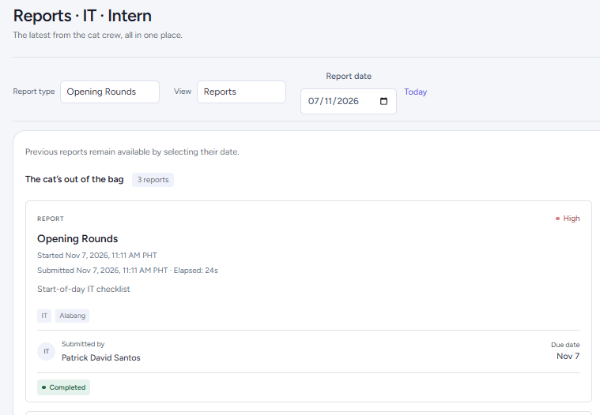
Employee: Luigi Maloles
TD- No. TM13 – Task Module
Route: /task-module and related record actions
Test Scenario: An opening rounds report is dismissed by the IT Supervisor due to no IT associates/interns being present in a branch.
Test Credentials: IT Supervisor preview
Test Data: IT Supervisor; opening rounds report; Dismiss for today.
Expected Result: IT Supervisor can dismiss the opening rounds report for the day and is reflected to all IT employees
Actual Result: IT Supervisor can dismiss the opening rounds report for the day and is reflected on all IT employees
Status: PASSED
Tester: David Santos
Screenshots:
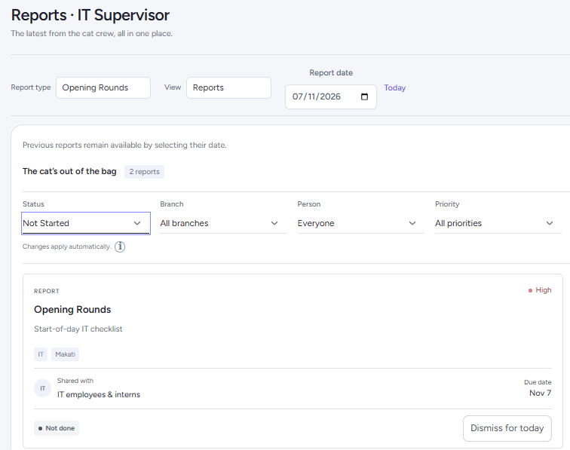
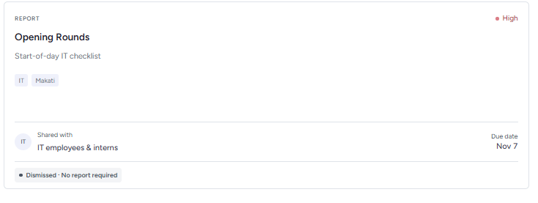

TD- No. TM14 – Task Module
Route: /task-module and related record actions
Test Scenario: Narrative summaries are compared with the owner’s approved task completions in each period, unfinished work and reports are not included.
Test Credentials: Admin account — preview as a selected narrative-report owner
Test Data: One approved completed task within the period
Expected Result: Only eligible owner completions in the selected period appear in the summary.
Actual Result: Only eligible owner completions in the selected period appear in the summary.
Status: PASSED
Tester: David Santos
Screenshots:
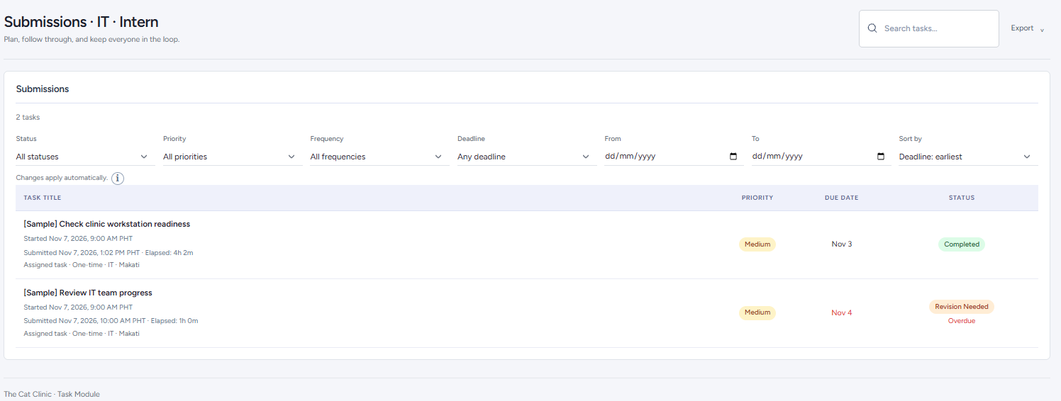
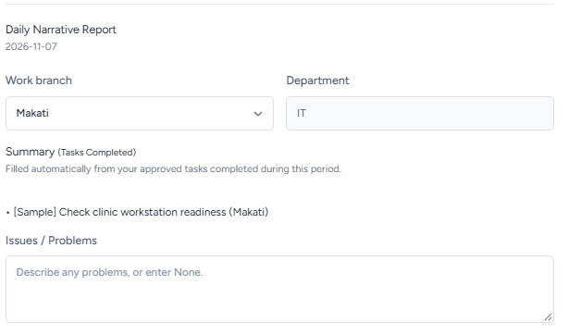

TD- No. TM15 – Task Module
Route: /task-module and related record actions
Test Scenario: An owner sends a task to an eligible recipient with handover notes, including a department chosen in Receiving department. The request is inspected in Sent and Received while pending to check that responsibility and the deadline remain with the current assignment until acceptance.
Test Credentials: Admin account — current-owner and recipient previews
Test Data: One unfinished standard task; current owner; active recipient in a selected department who can work at the task’s branch; notes identifying finished and remaining work; original owner, task ID and deadline.
Expected Result: Offer with notes leaves ownership unchanged and is visible to sender and recipient.
Actual Result: Offer with notes leaves ownership unchanged and is visible to sender and recipient.
Status: PASSED
Tester: David Santos
Screenshots:
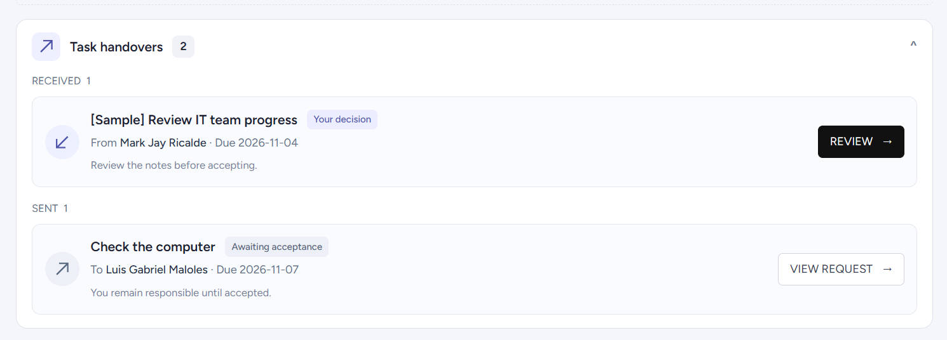
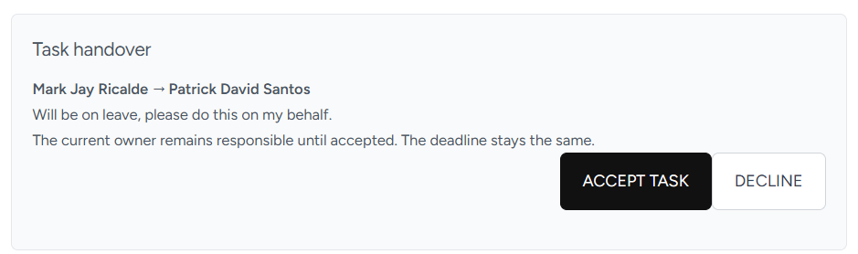

TD- No. TM16 – Task Module
Route: /task-module and related record actions
Test Scenario: A recipient accepts an eligible handover and the task is checked for its new owner and receiving department. The original deadline and previous work are inspected, then the new owner starts their own work interval.
Test Credentials: Admin account — current-owner and recipient previews
Test Data: One started individual standard task; saved previous output where available; current owner and original department; original task ID and deadline; pending handover notes.
Expected Result: Same task and deadline remain. Old work stays; new timer starts separately; credit is not doubled.
Actual Result: Same task and deadline remain. Old work stays; new timer starts separately; credit is not doubled.
Status: PASSED
Tester: David Santos
Screenshots:
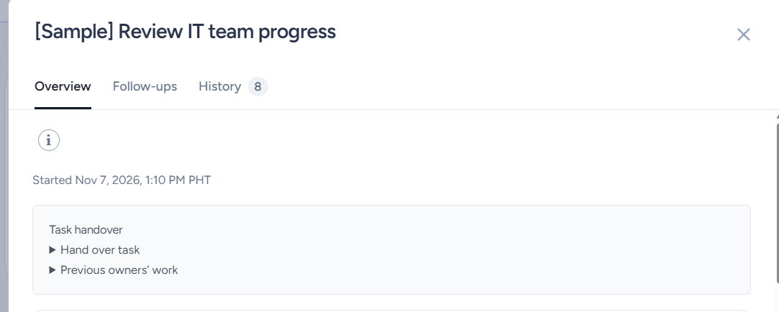

TD- No. TM17 – Task Module
Route: /task-module and related record actions
Test Scenario: An unrelated user attempts a handover decision, the recipient declines one offer and an authorized owner or manager cancels another. Assignment details and history are compared after each decision.
Test Credentials: Admin account — switch View as role and selected person as required for this scenario. Record the roles and people actually used.
Test Data: Two successive offers for one eligible task; original owner and department; recipient; unrelated account; decline and cancellation decisions; original deadline and saved history.
Expected Result: Authorized decisions retain original ownership; unrelated users cannot decide.
Actual Result: Unrelated user cannot view any handover request. Recipients can decline and the original owner still owns the current task. Created handovers can be canceled by the original owner of the task.
Status: PASSED IN ADMIN PREVIEW
Tester: David Santos
Screenshots:
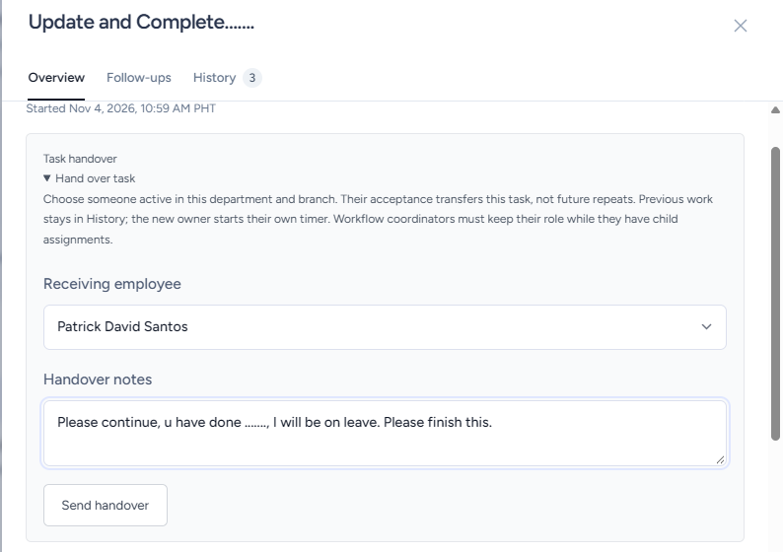
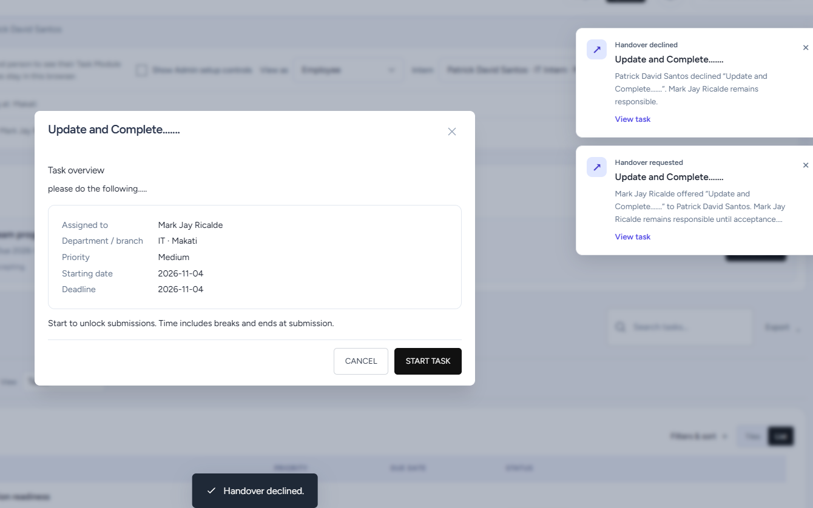

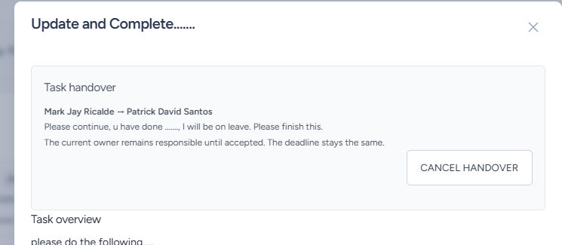
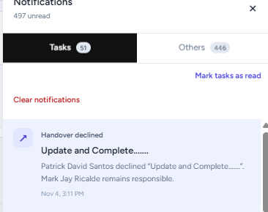

TD- No. TM18 – Task Module
Route: /task-module and related record actions
Test Scenario: Handover is attempted for reports, closed work, approval or review waits and a coordinator task with child assignments. An eligible unfinished individual standard task provides a valid comparison.
Test Credentials: Admin account — switch View as role and selected person as required for this scenario. Record the roles and people actually used.
Test Data: One report, one Completed task, one Pending Approval task, one Pending Review task, one coordinator with children and one unfinished standard task; authorized owners or managers for each.
Expected Result: Reject reports, closed tasks, approval or review waits and coordinators with children.
Actual Result: Main deliverable was able to be completed from the approved children tasks.
Status: PASSED IN ADMIN PREVIEW
Tester: David Santos
Screenshots:

TD- No. TM19 – Task Module
Route: /task-module and related record actions
Test Scenario: A valid XLSX row is imported, followed by a workbook with a required field missing. Imported status and output values are checked for approval bypass. A notification is cleared and the associated task and report history are checked for retention.
Test Credentials: Admin account — preview a role with import access, then use its task/history views
Test Data: The page’s downloaded XLSX template; one valid standard-task row with eligible assignee, department, branch, priority and dates; a second workbook with blank title; optional comparison columns status=Completed and submission=Test output; one existing task notification and saved report history.
Expected Result: Import follows permissions. Clearing notifications preserves task and report history.
Actual Result: Import follows approval and other permissions. Clearing notifications preserves task and report history.
Status: PASSED
Tester: David Santos
Screenshots:
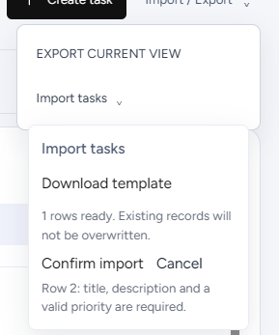

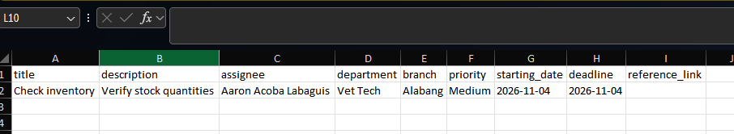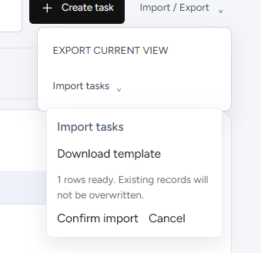
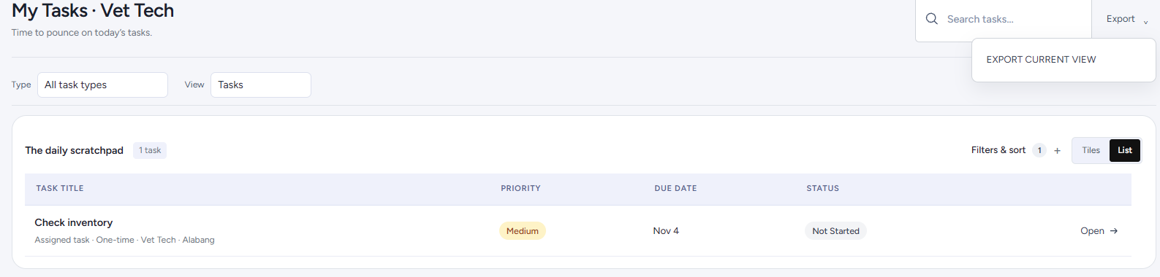
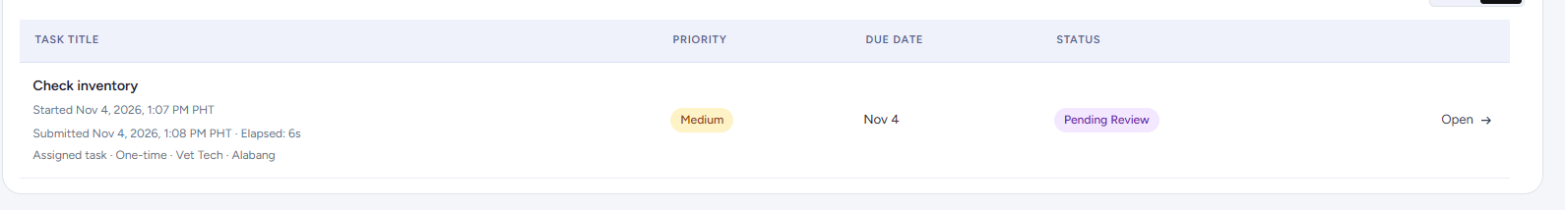
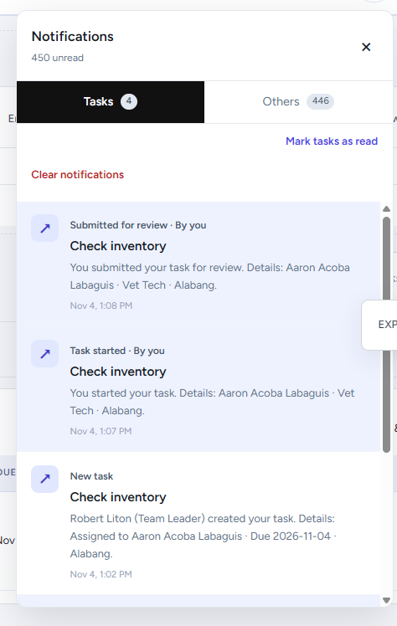

TD- No. TM20 – Task Module
Route: /task-module and related record actions
Test Scenario: Overdue Tasks from employees are presented in the calendar, Team Tasks and Leaderboards.
Test Credentials: Admin account — current-owner and recipient previews
Test Data: Overdue Tasks, Calendar, Leaderboard, Team Tasks
Expected Result: A red icon/warning displays on each page and allows the user to view which task is overdue.
Actual Result: A red icon/warning displays on each page and allows the user to view which task is overdue.
Status: PASSED
Tester: David Santos
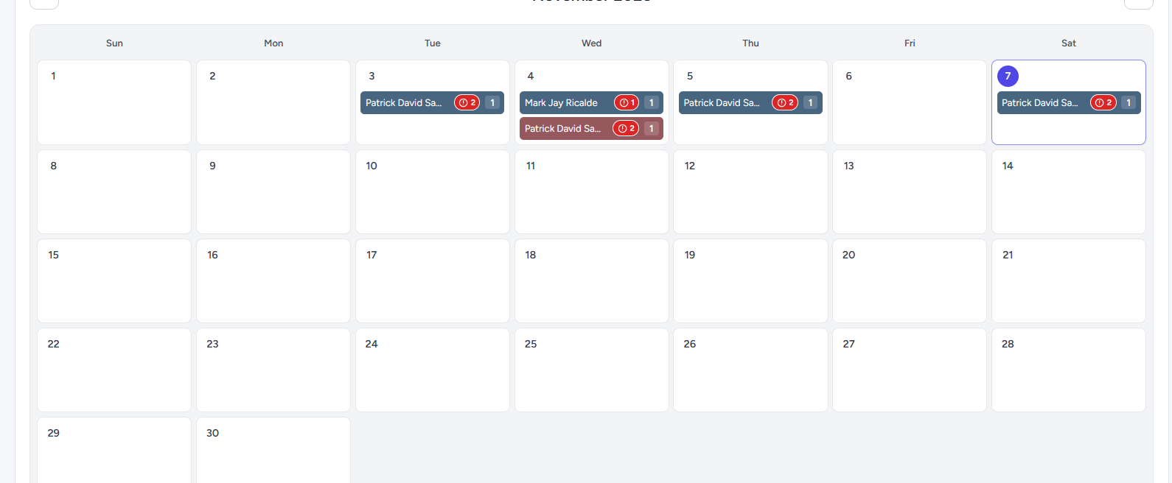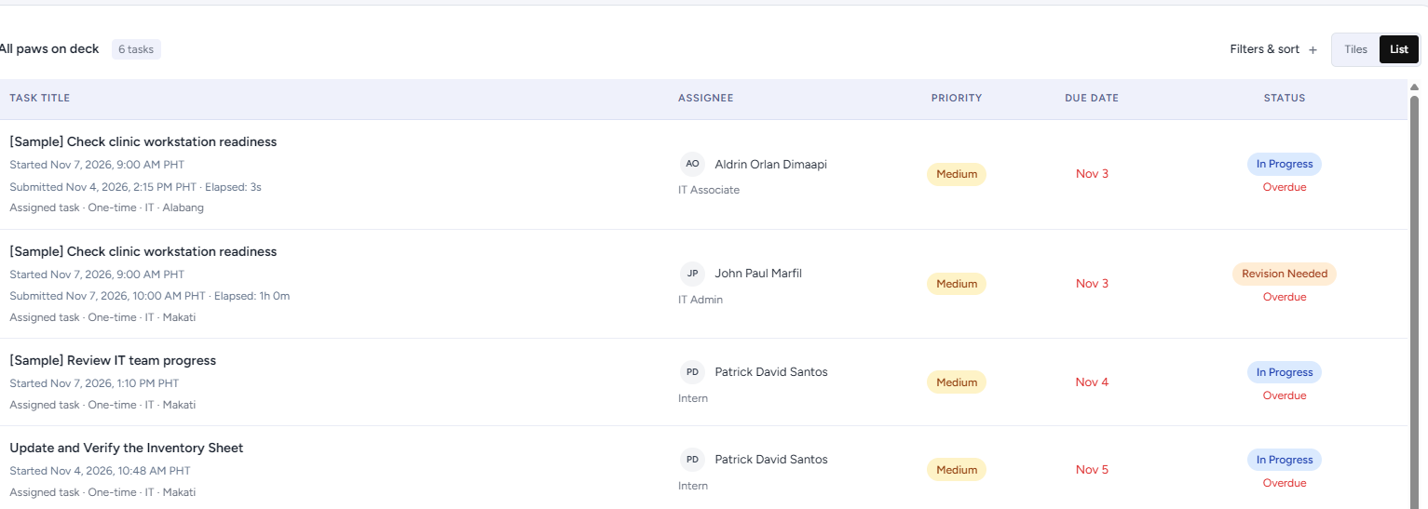
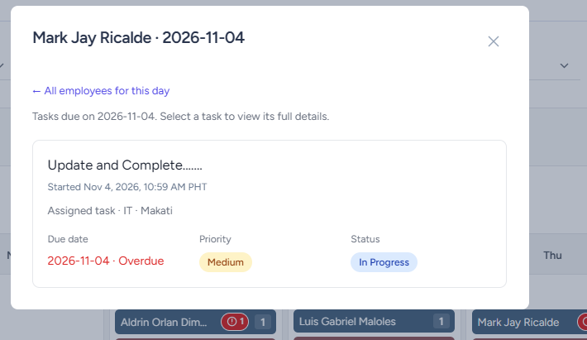

TD- No. TM21 – Task Module
Route: /task-module and related record actions
Test Scenario: Overdue Tasks from employees are presented in the calendar, Team Tasks and Leaderboards.
Test Credentials: Admin account — current-owner and recipient previews
Test Data: Overdue Tasks, Calendar, Leaderboard, Team Tasks
Expected Result: A red icon/warning displays on each page and allows the user to view which task is overdue.
Actual Result: A red icon/warning displays on each page and allows the user to view which task is overdue.
Status: PASSED
Tester: David Santos
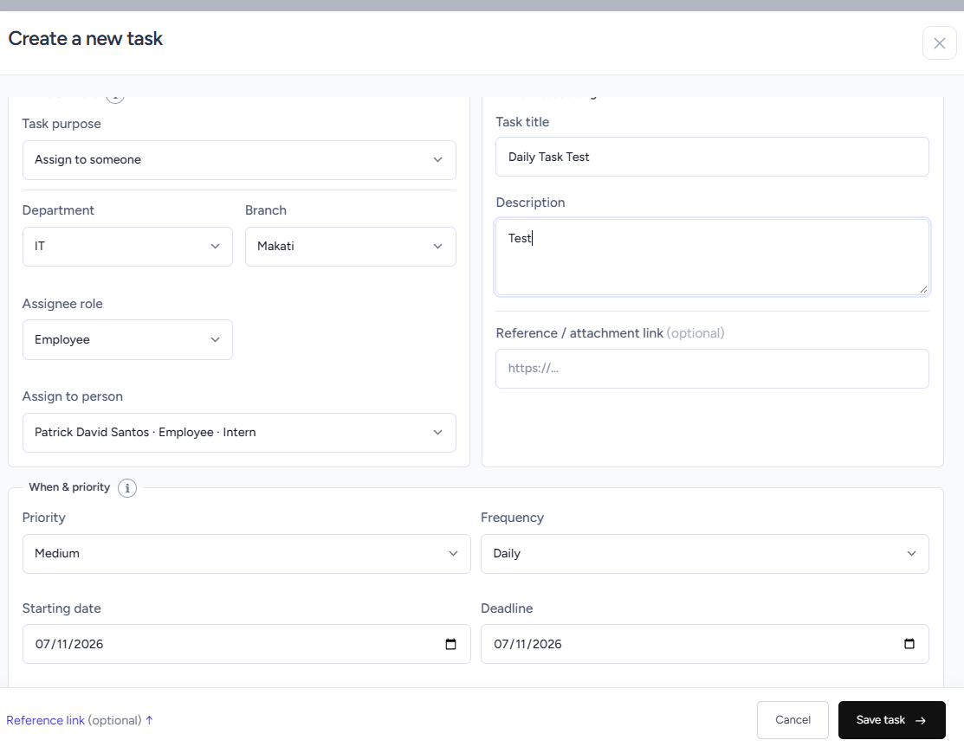
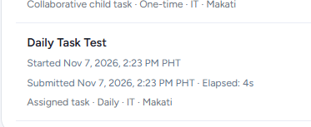
*Insert next day refresh task*

3. TEST DATA
3. TEST DATA
A. Graybox Testing
Graybox testing checks the Task Module through normal user actions and by reviewing the saved result. The test cases use this approach to check who can see and do each action, where approval goes, and whether changes appear in the task history. A test case is not complete until someone performs it and records what happened.
The tests are intended to check that:
• Each role can see and use only the pages and actions allowed for it.
• Assignments, approvals, submissions, returns, collaboration and handovers follow the stated workflow.
• Reports, calendar entries, imports, exports, notifications and history show the correct records.
• Errors and missing rules are recorded so they can be corrected and checked again.
B. Scope of Test Data Coverage
The test data covers the Task Module and actions connected to its records, including:
• Employee status and task access by role, department and branch.
• Creating, assigning, starting, submitting, approving, returning and denying tasks.
• Collaborative tasks, coordinator and child assignments, prerequisites and deadlines.
• Opening Rounds, narrative reports, intern reports and repeating tasks.
• Handovers, notifications, activity, history, imports, exports, concurrent edits, calendar and leaderboard.
C. Test Accounts and Role-Based Data
Use the signed-in Admin account and View as role to check how the Task Module looks for a selected role and person. Do not create test email credentials for these preview checks.
• For each preview, write down the signed-in account, the selected role and person, and the department or branch shown.
• View as role changes the role, person and profile name displayed in the Task Module. The signed-in account still controls server permissions.
• A preview shows what appears on screen. It does not prove that a separate user account is allowed or blocked by the server.
• If a check needs a separate account and one is not used, mark it Not Executed. Use Passed in Admin Preview only for an interface check that was actually performed.
• Remove Admin preview and setup controls before the live release.
D. Test Data Design
Use clearly labelled sample records that are separate from real work. Do not put client, patient, financial or other confidential information in test records. Keep a note of the record IDs used so each result can be traced to its test data.
• Staff and assignments: Use Employee Management to check the person’s name, active status, role, department and branch. For EVP scope checks, prepare tasks assigned to an OM, a Corporate Services member and a Team Leader. Include an employee task only when the case checks whether employee-level work is excluded; do not assume the EVP can create employee tasks.
• Task states and dates: Use separate records for Not Started, In Progress, Pending Approval, Pending Review, Revision Needed, Completed and Overdue. Reach each state through the normal task steps. An imported status does not count as approval. Use a past deadline for an unfinished overdue task. Import dates must use YYYY-MM-DD. A deadline may be the same day as the starting date, but not earlier.
• Collaborative work and reports: Prepare the main task, coordinator assignment and child assignment, and note each record’s owner, role, department, branch, deadline and prerequisite. Each assignment needs its own text or link submission. For report checks, use an approved task completed during the report period; keep sample records separate from real reports.
• Repeating tasks, handovers and history: Note the frequency and IDs of generated task occurrences. For handover checks, use an unfinished sample task and record its current owner, saved work, deadline and eligible recipient. Use separate examples for accepting, declining and cancelling a handover.
• Imports and concurrent edits: Download the XLSX template from the page being checked and keep its headings. Prepare one valid row and one row with a required value missing. To check simultaneous edits, open the same editable sample record in two independent sessions before saving either change.
• Cleanup: Record each sample record’s starting and final state. Do not delete activity logs or change real work to reset a test. Remove or close only labelled sample records when authorized, and keep evidence needed for review.
E. Validation Behavior Summary
At the time this document was prepared, the recorded results show 19 cases marked Passed and 2 marked Passed in Admin Preview. These counts describe only the results written in the test cases.
• Passed means the performed check matched its expected result.
• Passed in Admin Preview means the screen behaved as expected in preview; it does not confirm server permissions for another account.
• A result does not prove that other roles, branches or workflows were checked. Review each case and its evidence separately.
F. Test Execution Outcome
Use these statuses when recording each test:
• Not Executed — the check has not been performed.
• Passed — the observed result matched the expected result.
• Passed in Admin Preview — the interface check passed in preview, but server access was not independently checked.
• Failed — the observed result did not match the expected result.
• Blocked — another issue prevented the check from being completed.
For every case, record what actually happened, who performed the check and a screenshot of the relevant action and result. Do not mark a case as passed based only on its expected result.
G. Conclusion
This section explains what sample data the Task Module checks use and how to record the results. The test cases cover task access and workflow, reports, collaboration, handovers and record history.
The results currently recorded are 19 Passed and 2 Passed in Admin Preview. They apply only to the checks documented and performed. Preview results show the interface; separate signed-in accounts are needed to confirm server-side access.
Review each result and its evidence before deciding whether a feature is ready. Complete checks that are still marked Not Executed, and correct or formally accept any gaps before release.
Before live release, remove Admin preview and setup controls. Release readiness depends on reviewing the recorded checks and resolving or accepting the outstanding issues.

